**Exploring the Fascinating World of Birds at Agastya Academy**

At Agastya Academy, our journey into the fascinating world of birds began when our Managing Director, Mrs. Vidhya Chendhil, arranged a delightful bird camp expertly guided by Chandrasekaran Sir. This experience turned into an Adventure, and his guidance helped us delve deeper, learning about the intricacies of birds.

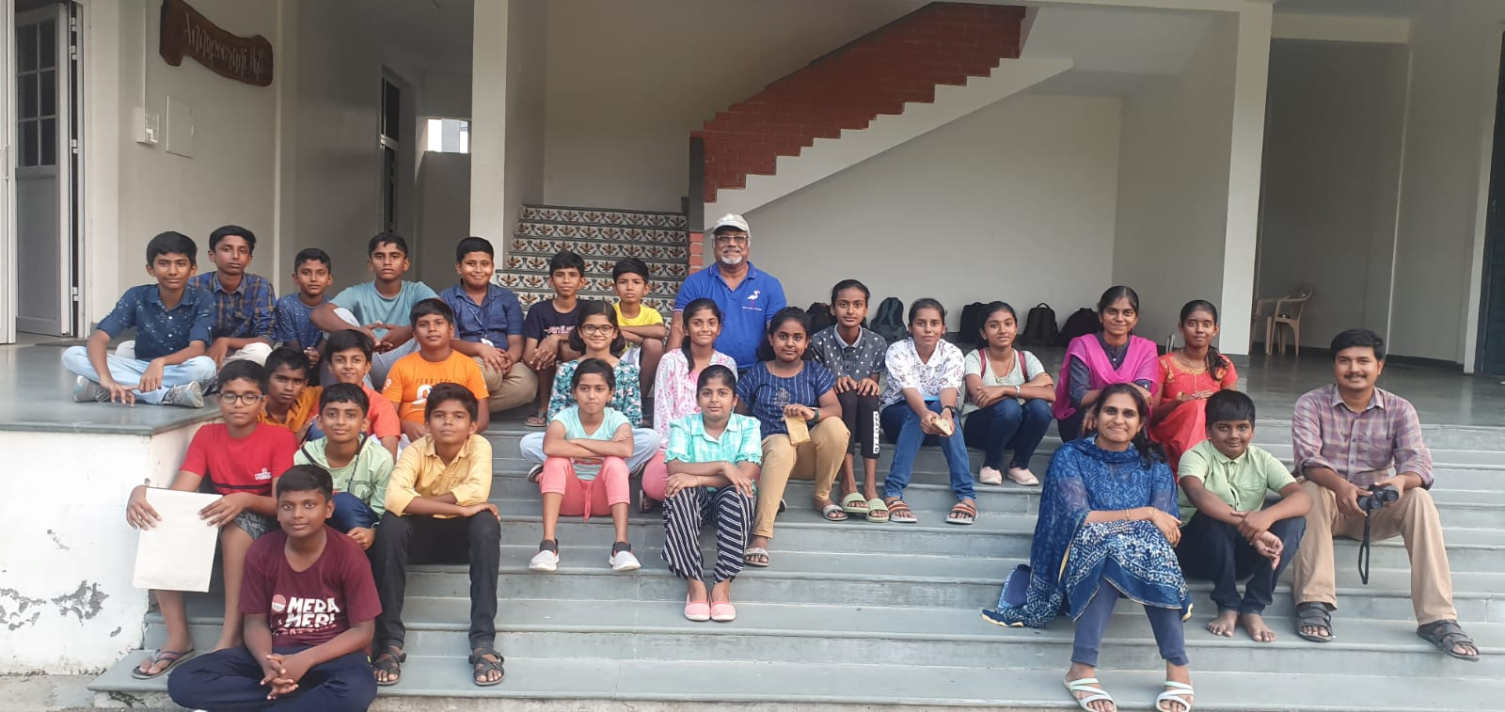Through our Bird Block study and the guidance of bird uncle, we've not only discovered the diversity and wonders of the fascinating world of birds but also developed a newfound passion for these feathered creatures. He shared several new and really useful pieces of information that made us bird experts in no time. Now, we're not just bird enthusiasts; we're also mini bird experts and feel super confident explaining all about these birds to anyone keen on exploring nature.

[Click here to read more………..](https://www.agastyaacademy.edu.in/post/exploring-the-fascinating-world-of-birds-at-agastya-academy)